Project Proposal & Preliminary Design

Alberto Martinez

CST324 – Databases

Submitted to: Todd Breedlove

CSET Professor, Oregon Institute of Technology

November 5, 2008

Table of Contents

Project Description 1

Requirement Specification / Business Rules 2

ER Diagram 3

Create Table Statements 4

# Project Description

This project will describe an ice maintenance system generalized for any ice rink, with any collection of different ice slabs. There is currently no system available to keep track of the ice maintenance activities of an ice rink. Working at the Bill Collier Community Ice Arena and Sun Valley Company, I have been a large part of ice maintenance for about 2 years. At BCCIA, the system is currently paper-bound keeping track of ice height, ice temperature, air temperature, weather conditions and other ice maintenance related events. My goal here will be to implement the computerized version of this system and generate reports of the current condition of the ice to guide ice maintenance workers to what they need to do in order to keep the ice at its optimal condition.

# Requirement Specification / Business Rules

In order to generalize this system to work for more than one rink with potentially more than one slab of ice, I will need to know what the differences in ice slabs are. These tables will be described thusly. Once this is established, an easy-to-read coordinate system must be generated for different sized ice slabs, one that is easy to use for ice maintenance workers. Regulation hockey rink size is 85ft(26m) x 200ft(61m), this size is the most common for ice rinks because it is a more efficient to have ice that can be used by both hockey and figure skaters. Olympic sized ice rinks are 98ft(30m) x 200ft(61m). However, rink to rink the sizes may differ and ice rinks can be either indoor or outdoor. For the purposes of this document, regulation hockey rink size and painting will be used as data is already available for this particularly sized rink. This data will be provided by BCCIA and Klamath Ice Sports.

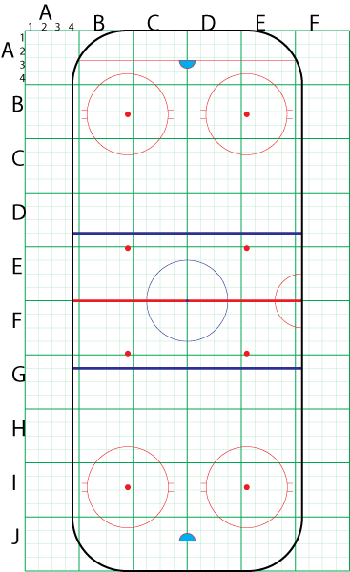

**Figure 1**: This figure illustrates an easy to use coordinate system. Coordinates might read as (CE44) which would be a small section on the upper left hand portion of center-ice. This figure is to-scale with official NHL rink measurements.

# ER Diagram



# Create Table Statements

n/a